| Please choose a lesson, or type 0 to return to course menu.

1: Principles of Analytic Graphs 2: Exploratory Graphs

3: Graphics Devices in R 4: Plotting Systems

5: Base Plotting System 6: Lattice Plotting System

7: Working with Colors 8: GGPlot2 Part1

9: GGPlot2 Part2 10: GGPlot2 Extras

11: Hierarchical Clustering 12: K Means Clustering

13: Dimension Reduction 14: Clustering Example

15: CaseStudy

Selection: 3

| | 0%

| Graphics_Devices_in_R. (Slides for this and other Data Science courses may be found at github

| https://github.com/DataScienceSpecialization/courses/. If you care to use them, they must be

| downloaded as a zip file and viewed locally. This lesson corresponds to

| 04_ExploratoryAnalysis/Graphics_Devices_in_R.)

...

|=== | 3%

| As the title suggests, this will be a short lesson introducing you to graphics devices in R. So,

| what IS a graphics device?

...

|===== | 6%

| Would you believe that it is something where you can make a plot appear, either a screen device,

| such as a window on your computer, OR a file device?

...

|======== | 9%

| There are several different kinds of file devices with particular characteristics and hence uses.

| These include PDF, PNG, JPEG, SVG, and TIFF. We'll talk more about these later.

...

|=========== | 12%

| To be clear, when you make a plot in R, it has to be "sent" to a specific graphics device. Usually

| this is the screen (the default device), especially when you're doing exploratory work. You'll send

| your plots to files when you're ready to publish a report, make a presentation, or send info to

| colleagues.

...

|============== | 15%

| How you access your screen device depends on what computer system you're using. On a Mac the screen

| device is launched with the call quartz(), on Windows you use the call windows(), and on Unix/Linux

| x11(). On a given platform (Mac, Windows, Unix/Linux) there is only one screen device, and

| obviously not all graphics devices are available on all platforms (i.e. you cannot launch windows()

| on a Mac).

...

|================ | 18%

| Run the R command ?Devices to see what graphics devices are available on your system.

warning messages from top-level task callback 'mini'

Warning message:

In readLines(input) :

incomplete final line found on 'C:/Program Files/R/R-3.2.3/library/swirl/Courses/Exploratory_Data_Analysis/Graphics_Devices_in_R/lesson'

> setwd("~/")

| You almost had it, but not quite. Try again. Or, type info() for more options.

| Type ?Devices at the command prompt.

> ?Devices

| That's a job well done!

|=================== | 21%

| R Documentation shows you what's available.

...

|====================== | 24%

| There are two basic approaches to plotting. The first, plotting to the screen, is the most common.

| It's simple - you call a plotting function like plot, xyplot, or qplot (which you call depends on

| the plotting system you favor, but that's another lesson), so that the plot appears on the screen.

| Then you annotate (add to) the plot if necessary.

...

|======================== | 26%

| As an example, run the R command with with 2 arguments. The first is a dataset, faithful, which

| comes with R, and the second is a call to the base plotting function plot. Your call to plot should

| have two arguments, eruptions and waiting. Try this now to see what happens.

> with(faithful, plot(eruptions, waiting))

| You got it!

|=========================== | 29%

| See how R created a scatterplot on the screen for you? This shows that relationship between

| eruptions of the geyser Old Faithful and waiting time. Now use the R function title with the

| argument main set equal to the string "Old Faithful Geyser data". This is an annotation to the

| plot.

> title(main = "Old Faithful Geyser data")

| That's a job well done!

|============================== | 32%

| Simple, right? Now run the command dev.cur(). This will show you the current plotting device, the

| screen.

> dev.cur()

RStudioGD

2

| All that practice is paying off!

|================================ | 35%

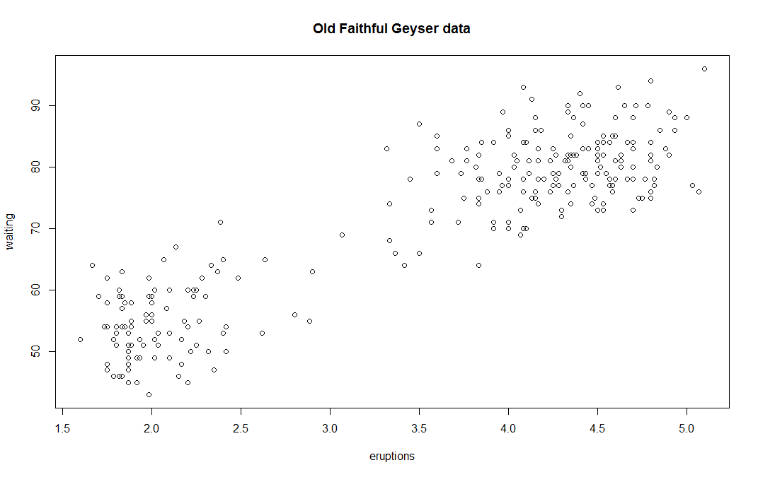

| The second way to create a plot is to send it to a file device. Depending on the type of plot

| you're making, you explicitly launch a graphics device, e.g., a pdf file. Type the command

| pdf(file="myplot.pdf") to launch the file device. This will create the pdf file myplot.pdf in your

| working directory.

> pdf(file = "myplot.pdf")

| You are doing so well!

|=================================== | 38%

| You then call the plotting function (if you are using a file device, no plot will appear on the

| screen). Run the with command again to plot the Old Faithful data. Use the up arrow key to recover

| the command and save yourself some typing.

> with(faithful, plot(eruptions, waiting))

| You are quite good my friend!

|====================================== | 41%

| Now rerun the title command and annotate the plot. (Up arrow keys are great!)

> title(main = "Old Faithful Geyser data")

| You got it right!

|========================================= | 44%

| Finally, when plotting to a file device, you have to close the device with the command dev.off().

| This is very important! Don't do it yet, though. After closing, you'll be able to view the pdf file

| on your computer.

...

|=========================================== | 47%

| There are two basic types of file devices, vector and bitmap devices. These use different formats

| and have different characteristics. Vector formats are good for line drawings and plots with solid

| colors using a modest number of points, while bitmap formats are good for plots with a large number

| of points, natural scenes or web-based plots.

...

|============================================== | 50%

| We'll mention 4 specific vector formats. The first is pdf, which we've just used in our example.

| This is useful for line-type graphics and papers. It resizes well, is usually portable, but it is

| not efficient if a plot has many objects/points.

...

|================================================= | 53%

| The second is svg which is XML-based, scalable vector graphics. This supports animation and

| interactivity and is potentially useful for web-based plots.

...

|=================================================== | 56%

| The last two vector formats are win.metafile, a Windows-only metafile format, and postscript (ps),

| an older format which also resizes well, is usually portable, and can be used to create

| encapsulated postscript files. Unfortunately, Windows systems often donâ€™t have a postscript

| viewer.

...

|====================================================== | 59%

| We'll also mention 4 different bitmap formats. The first is png (Portable Network Graphics) which

| is good for line drawings or images with solid colors. It uses lossless compression (like the old

| GIF format), and most web browsers can read this format natively. In addition, png is good for

| plots with many points, but it does not resize well.

...

|========================================================= | 62%

| In contrast, jpeg files are good for photographs or natural scenes. They use lossy compression, so

| they're good for plots with many points. Files in jpeg format don't resize well, but they can be

| read by almost any computer and any web browser. They're not great for line drawings.

...

|============================================================ | 65%

| The last two bitmap formats are tiff, an older lossless compression meta-format and bmp which is a

| native Windows bitmapped format.

...

|============================================================== | 68%

| Although it is possible to open multiple graphics devices (screen, file, or both), when viewing

| multiple plots at once, plotting can only occur on one graphics device at a time.

...

|================================================================= | 71%

| The currently active graphics device can be found by calling dev.cur(). Try it now to see what

| number is assigned to your pdf device.

> dev.cur()

pdf

4

| You nailed it! Good job!

|==================================================================== | 74%

| Now use dev.off() to close the device.

> dev.off()

RStudioGD

2

| You are really on a roll!

|====================================================================== | 76%

| Now rerun dev.cur() to see what integer your plotting window is assigned.

> dev.cur()

RStudioGD

2

| That's a job well done!

|========================================================================= | 79%

| The device is back to what it was when you started. As you might have guessed, every open graphics

| device is assigned an integer greater than or equal to 2. You can change the active graphics device

| with dev.set(<integer>) where <integer> is the number associated with the graphics device you want

| to switch to.

...

|============================================================================ | 82%

| You can also copy a plot from one device to another. This can save you some time but beware!

| Copying a plot is not an exact operation, so the result may not be identical to the original. R

| provides some functions to help you do this. The function dev.copy copies a plot from one device to

| another, and dev.copy2pdf specifically copies a plot to a PDF file.

...

|============================================================================== | 85%

| Just for fun, rerun the with command again, with(faithful, plot(eruptions, waiting)), to plot the

| Old Faithful data. Use the up arrow key to recover the command if you don't feel like typing.

> with(faithful, plot(eruptions, waiting))

| You are amazing!

|================================================================================= | 88%

| Now rerun the title command, title(main = "Old Faithful Geyser data"), to annotate the plot. (Up

| arrow keys are great!)

> title(main = "Old Faithful Geyser data")

| All that practice is paying off!

|==================================================================================== | 91%

| Now run dev.copy with the 2 arguments. The first is png, and the second is file set equal to

| "geyserplot.png". This will copy your screen plot to a png file in your working directory which you

| can view AFTER you close the device.

> dev.copy(png, file = "geyserplot.png")

png

4

| You are doing so well!

|======================================================================================= | 94%

| Don't forget to close the PNG device! Do it NOW!!! Then you'll be able to view the file.

> dev.off()

RStudioGD

2

| You are quite good my friend!

|========================================================================================= | 97%

| Congrats! We hope you found this lesson deviced well!

...

|============================================================================================| 100%

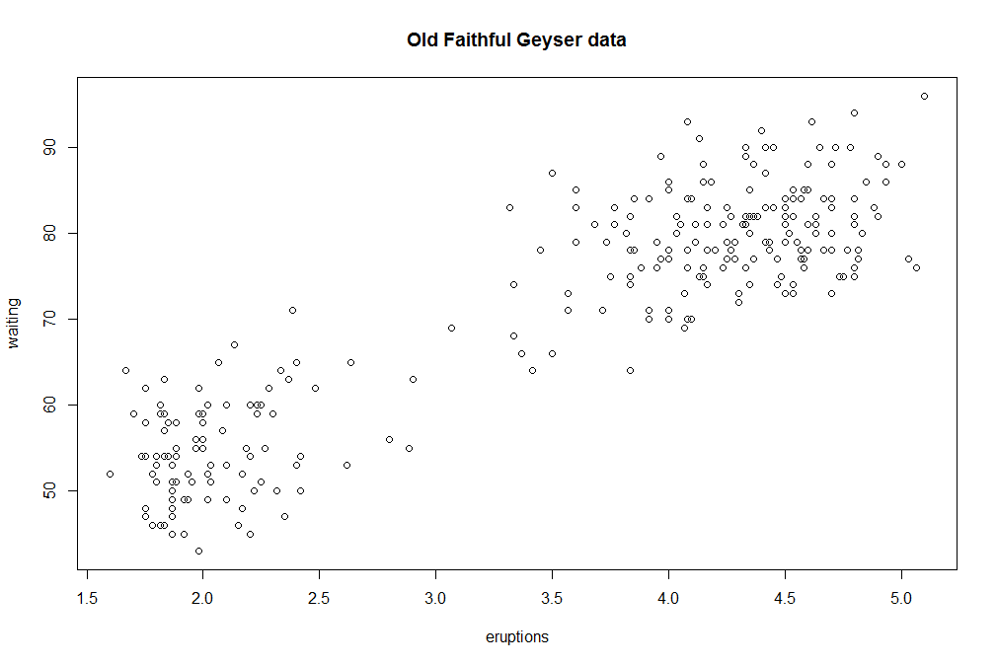

| The second way to create a plot is to send it to a file device. Depending on the type of plot

| you're making, you explicitly launch a graphics device, e.g., a pdf file. Type the command

| pdf(file="myplot.pdf") to launch the file device. This will create the pdf file myplot.pdf in your

| working directory.

> pdf(file = "myplot.pdf")

| That's correct!

|=================================== | 38%

| You then call the plotting function (if you are using a file device, no plot will appear on the

| screen). Run the with command again to plot the Old Faithful data. Use the up arrow key to recover

| the command and save yourself some typing.

> with(faithful, plot(eruptions, waiting))

| Keep working like that and you'll get there!

|====================================== | 41%

| Now rerun the title command and annotate the plot. (Up arrow keys are great!)